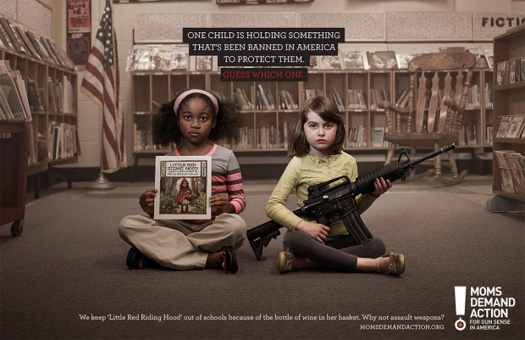Moms Demand Action for Gun Sense in America ad (2013) : Tom Williams/Roll Call/Getty Images
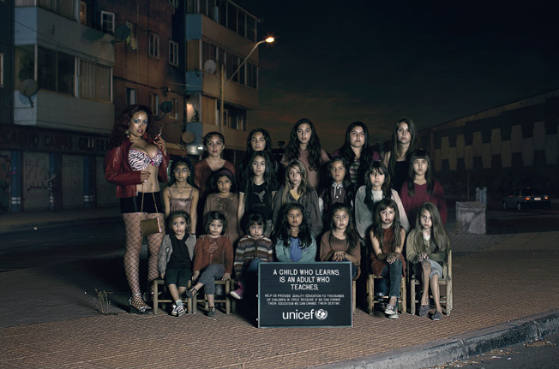
Unicef ad (2013). Agency: Prolam Y&R, Santiago Chile

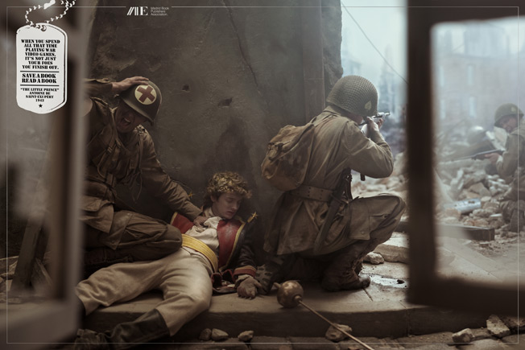
Madrid Book Publishers ad (2013). Agency: Grey, madrid
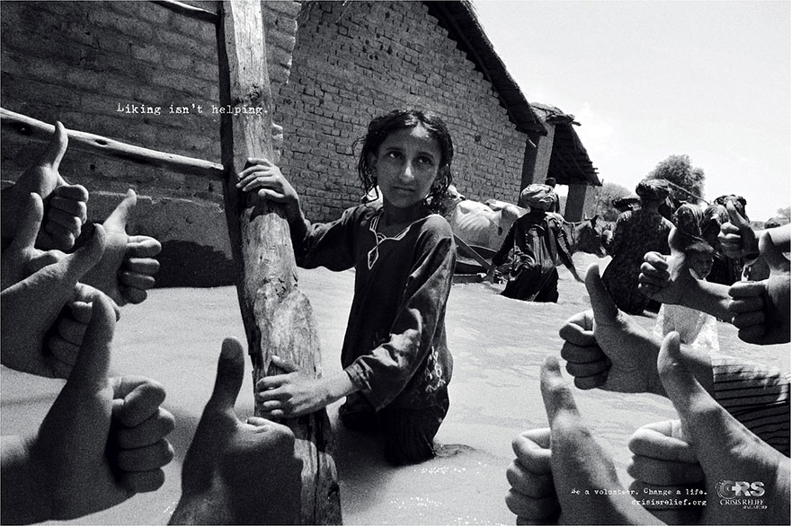
Crisis Relief Singapore ad (2013) Agency: Publicis, Singapore

